PowerProtect Data Manager

Plugin Configuration Guide

Contents

1 Introduction 2

2 Support 2

2.1 PowerProtect Data Manager versions 2

2.2 Backup types 2

2.3 Collection Types 2

2.4 Requirements 3

2.4.1 Data Sources 3

2.4.2 Firewall 3

3 Configure Data Collection 3

3.1 Checklist 3

3.2 Add Server 3

3.3 Server Properties 4

4 Troubleshooting 5

4.1 Test Connection 5

5 Bocada Technical Support 5

# Introduction

This guide details how to configure Bocada data collection for PowerProtect Data Manager servers.

# Support

## PowerProtect Data Manager versions

Bocada 22.1.4 introduces support for PowerProtect Data Manager.

Supported version starts with PowerProtect Data Manager v19.9.0-19 (Dell EMC). Older versions of PowerProtect Data Manager might work but have not been tested and are not supported.

## Backup types

The Bocada plugin for PowerProtect Data Manager reports on the following Jobs:

* Protection Jobs
* System Jobs (Cloud Disaster Recovery, Cloud Copy Recover, Disaster Recovery)

## Collection Types

The PowerProtect Data Manager plugin supports the following collection types:

|  |  |  |
| --- | --- | --- |
| **Collection Type** | **Supported** | **Description** |
| **Backup Jobs** | **✓** | Collects transactional details about protection and disaster recovery jobs. Example metrics include start times, durations, bytes, errors etc. This does not include In Progress jobs |
| **In Progress Jobs** |  | Collects information on backups that are running or have completed since the previous full Backup jobs data collection. These updates are included in the Backup updates, but are lightweight and can be scheduled more often than backup updates if needed. |
| **Storage** |  | Collects point-in-time inventory information. Example metrics include, total recoverable gigabytes (storage), media volume count, media volume status, etc. |
| **Policy** |  | Collects and stores information on policy attributes, schedules, storage units, storage groups, storage lifecycle policies and clients. |

## Requirements

### Data Sources

The plugin relies on the PowerProtect Data Manager 19.9 REST API (the current API version is v2). REST API Technical documentation can be found here <https://developer.dell.com/apis/4378/versions/19.9/docs/introduction.md>

### Firewall

When connecting to PowerProtect Data Manager through a firewall, make sure to open the following ports for communication with the Bocada Data Collection Server(s).

|  |  |  |
| --- | --- | --- |
| **Daemon / Service** | **Default** | **Notes** |
| **REST API** | **8443** | Default port for PowerProtect Data Manager REST API. |

# Configure Data Collection

## Checklist

Please ensure the following information is available when you start configuring the PowerProtect Data Manager plugin:

|  |  |  |
| --- | --- | --- |
| Step | Check | Description |
| 1 | ☐ | **Username** and **Password** for Bocada to connect to PowerProtect Data Manager REST API. The user needs read only role. Here is the link to check the access role <https://developer.dell.com/apis/4378/versions/19.9/docs/getting%20started/authentication-and-authorization.md> |
| 2 | ☐ | PowerProtect Data Manager RESTP API Port. Default Port is 8443 |

## Add Server

Select the Backup Server entry from the right Action panel and click on the Add Server icon, as shown below. The “Add Server” dialog opens.

## Server Properties

Server Properties determine how the plugin will interface with the PowerProtect Data Manager and how the plugin is managed through the Backup Servers view.

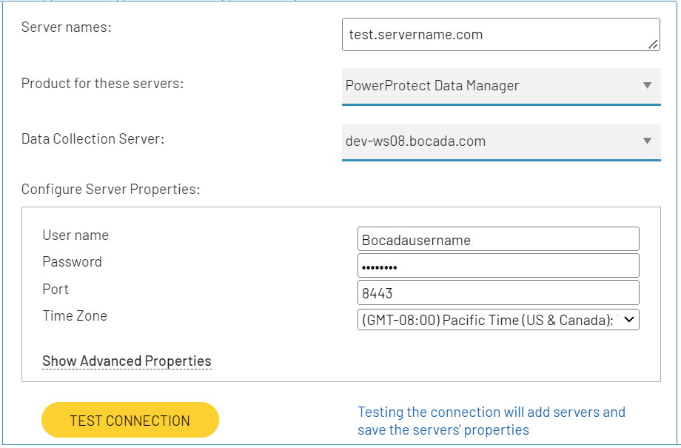

#### Field Definitions

|  |  |
| --- | --- |
| **Field Name** | **Description** |
| Server name | Enter a name for the PowerProtect Data Manager server name. |
| Backup Product | Select PowerProtect Data Manager from the dropdown menu |
| Username | Username to authenticate onto PowerProtect Data Manager REST API. |
| Password | Password to authenticate onto PowerProtect Data Manager REST API. |
| Port | REST API port (default port is 8443). |
| Time Zone | Select the time zone where PowerProtect Data Manager server resides.  This setting ensures times are displayed consistently in environments that span multiple time zones. |

# Troubleshooting

## Test Connection

Test Connection validates the server properties by connecting to authenticate to PowerProtect Data Manager REST API.

* A **Successful** test connection indicates connection and logon is successful and data collection is ready to be scheduled.
* A **Failed** test connection indicates the network connection is blocked, the server name is incorrect, or the user credentials cannot access the REST API.

# Bocada Technical Support

For technical support, or for a copy of our standard support agreement, please contact us.

|  |  |
| --- | --- |
| **E-mail:** | [support@bocada.com](mailto:support@bocada.com) |
| **Phone:** | +1-425-898-2400 |
| **Support Portal:** | <https://bocada-support.force.com> |

**Copyright © 2022 Bocada LLC.** All Rights Reserved. Bocada and BackupReport are registered trademarks of Bocada LLC. Vision, Prism, vpConnect, and the Bocada logo are trademarks of Bocada LLC. Other product names mentioned herein may be trademarks or registered trademarks of their respective companies.

Protected by U.S patents 6,640,217; 6,708,188; 6,745,210; 7,457,833; 7,469,269; 7,496,614; 8,407,227

The material in this manual is for information only and is subject to change without notice. While efforts have been made to ensure accuracy, Bocada LLC assumes no liability resulting from errors or omissions in this document, or from the use of information contained herein.

Bocada LLC reserves the right to make changes to the product design and documentation without reservation and without notification to its users. 2022-04-05